Computer Vision hw_1

By R01922124 許彥彬

Part I.

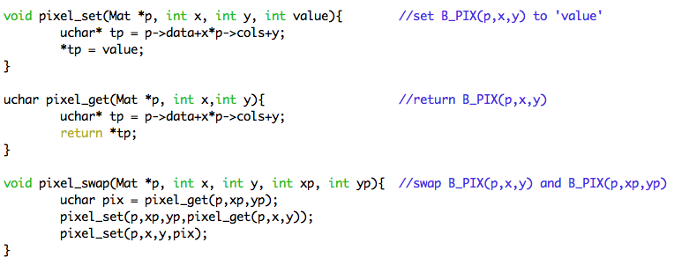 In this part the OpenCV-2.4.2 I/O function was included.

Three functions as follow will be use in the algorithms below.

1. Upside-down lena.im  
   main algorithm:  
   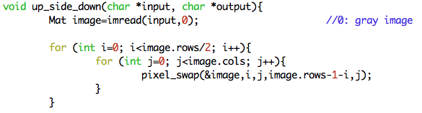  
   result:

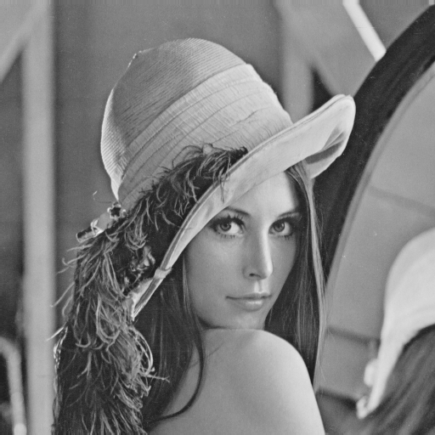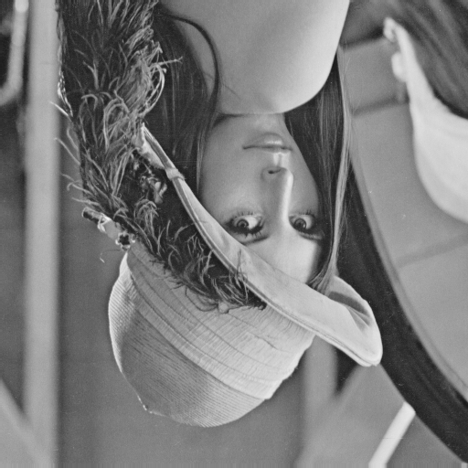

1. Right-side-left lena.im  
   main algorithm:  
   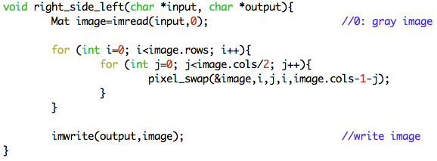  
   result:

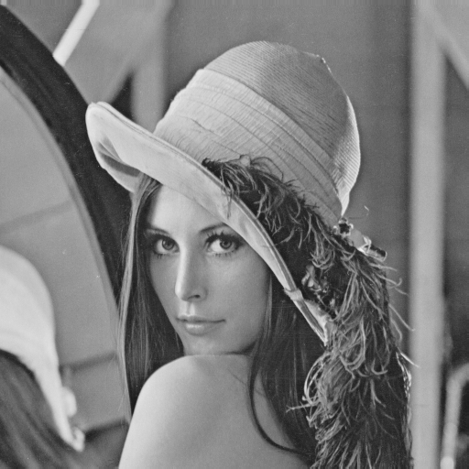

1. Diagonally mirrored lena.im

main algorithm:  
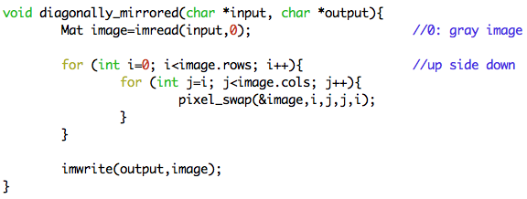  
result:

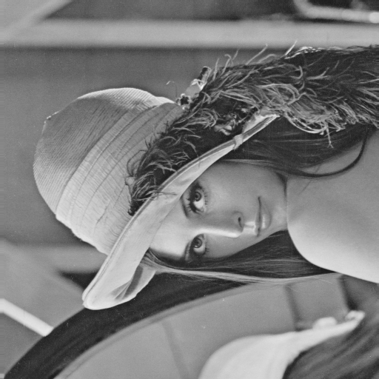

Part II. (Using Photoshop CS6)

1. Rotate lena.im 45 degrees clockwise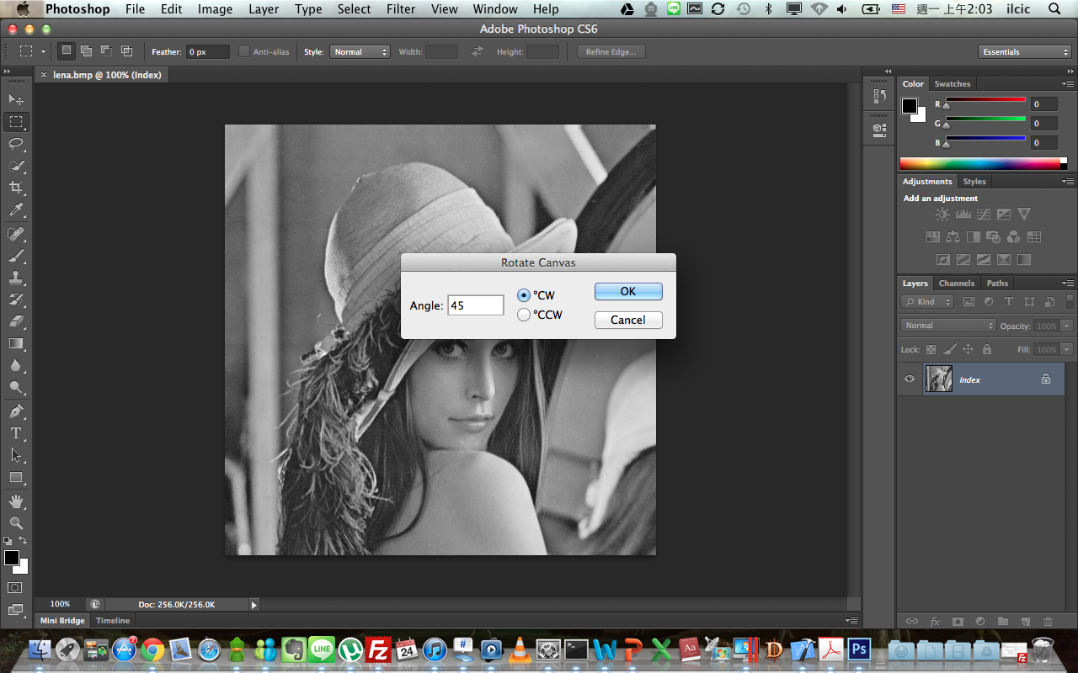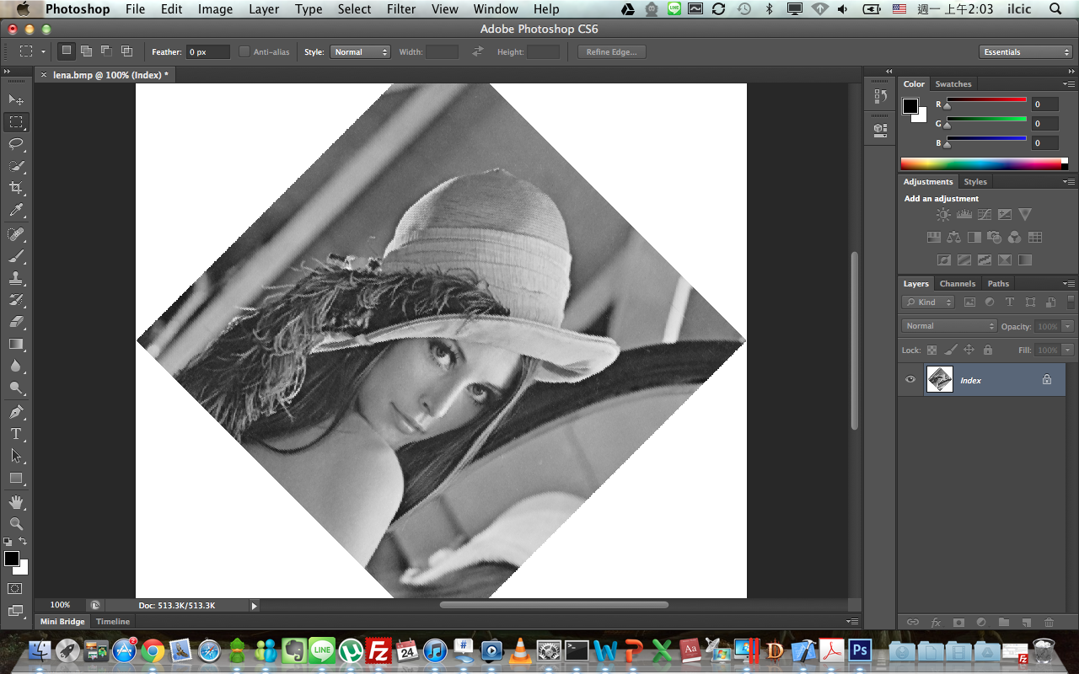
2. Shrink lena.im in half  
   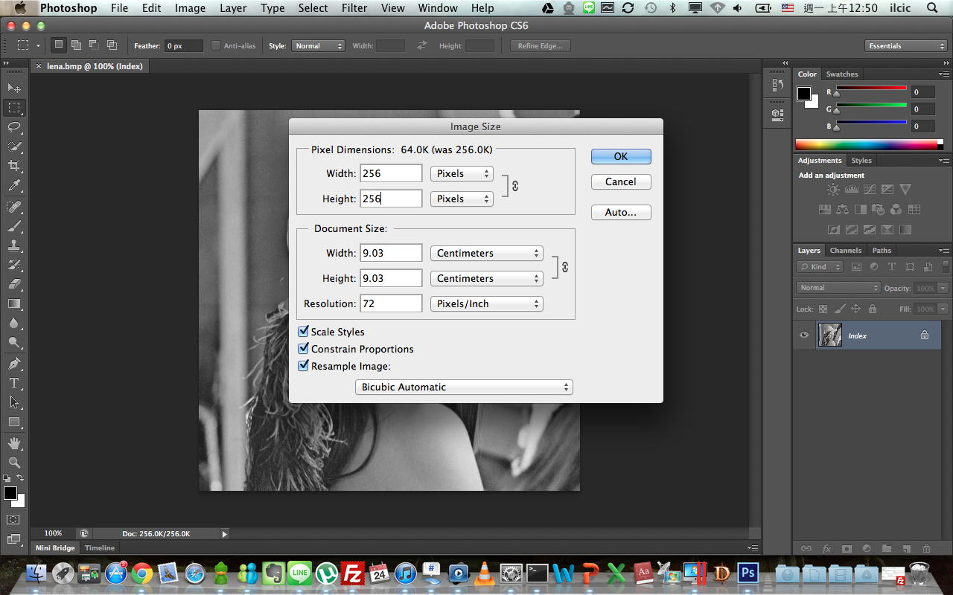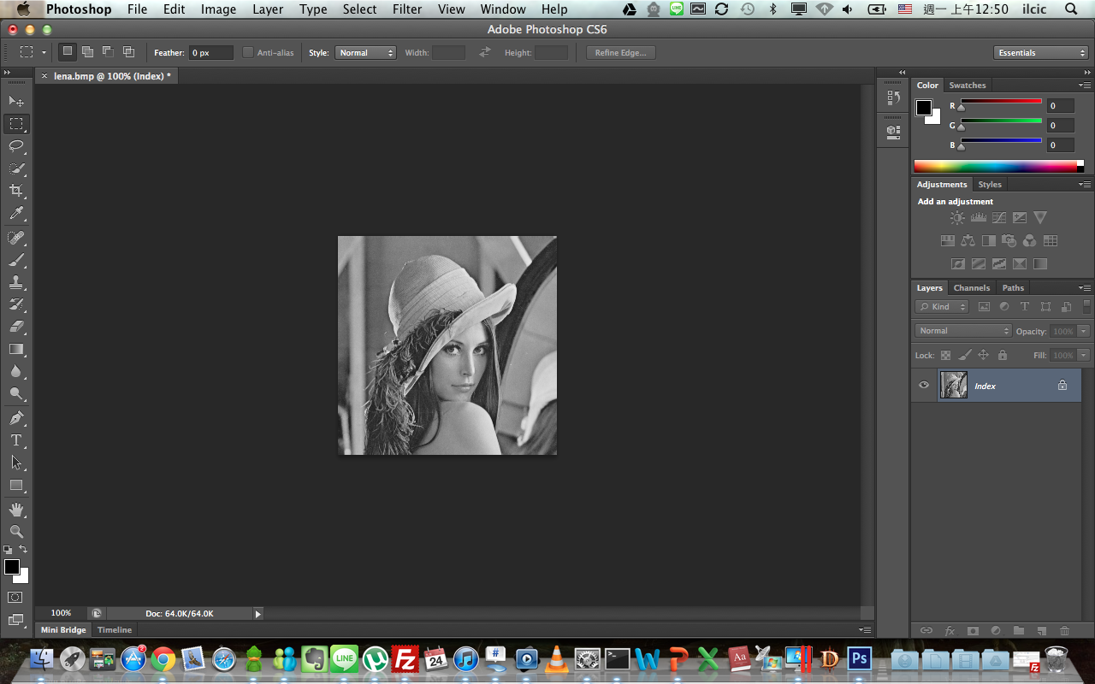
3. Binarize lena.im at 128 to get a binary image

